MyRegent按尺码组打印

适用范围：尺码组多的客户

一、代码调整

1、屏蔽代码

private void PageHeader_BeforePrint(object sender, System.Drawing.Printing.PrintEventArgs e) {

/*

PageHeaderBand pageHeader = (PageHeaderBand)sender;

XtraReport rpt = (XtraReport)pageHeader.Report;

DataSet ds = (DataSet)pageHeader.Report.DataSource;

//int sizeCount = ReportManager.SizeManager.GetSizeCount();

//string sizeClass = pageHeader.Report.GetCurrentColumnValue("SizeClass").ToString();

ReportManager.SizeManager.ParseSizeHeader(rpt, ds, "", "tcSizeHeader", sizeCount);

ReportManager.SizeManager.ParseSizeClassHeader(rpt, ds, "", "tcSizeClass", sizeCount);

*/

}

2、添加代码

private void GroupHeader2_BeforePrint(object sender, System.Drawing.Printing.PrintEventArgs e) {

GroupHeaderBand pageHeader = (GroupHeaderBand )sender;

XtraReport rpt = (XtraReport)pageHeader.Report.Report;

DataSet ds = (DataSet)pageHeader.Report.DataSource;

//int sizeCount = ReportManager.SizeManager.GetSizeCount();

string sizeClass = pageHeader.Report.GetCurrentColumnValue("Size_Class").ToString();

ReportManager.SizeManager.ParseSizeHeader(rpt, ds, sizeClass, "tcSizeHeader", sizeCount);

ReportManager.SizeManager.ParseSizeClassHeader(rpt, ds, sizeClass, "tcSizeClass", sizeCount);

}

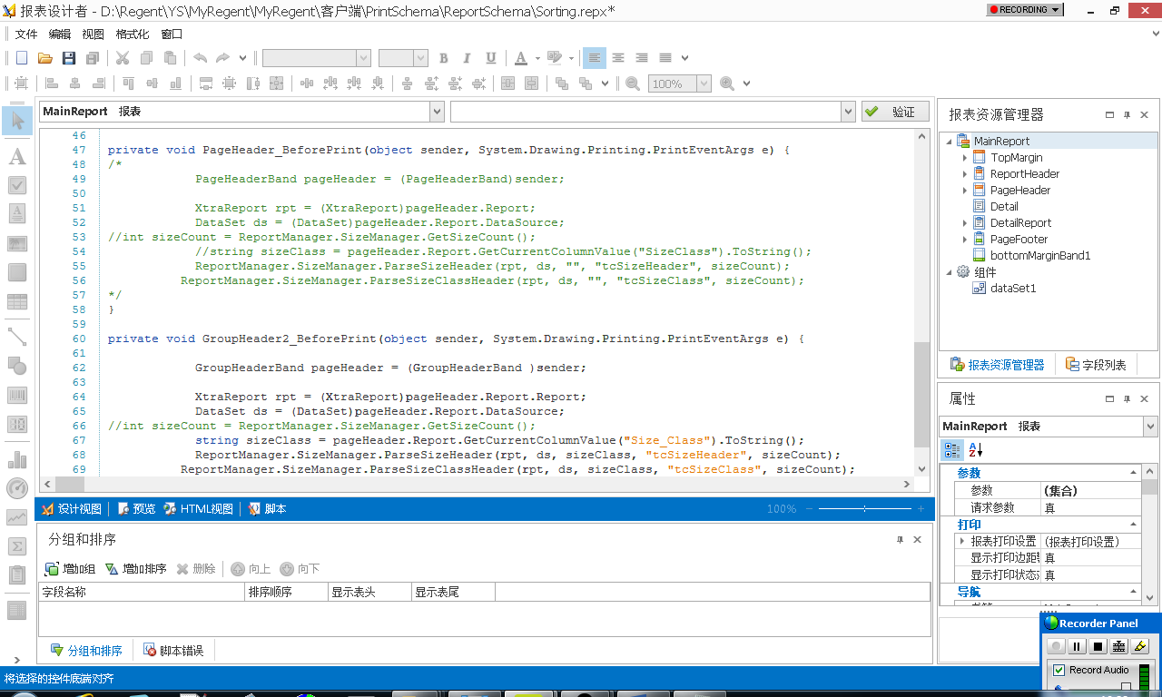

二、界面调整

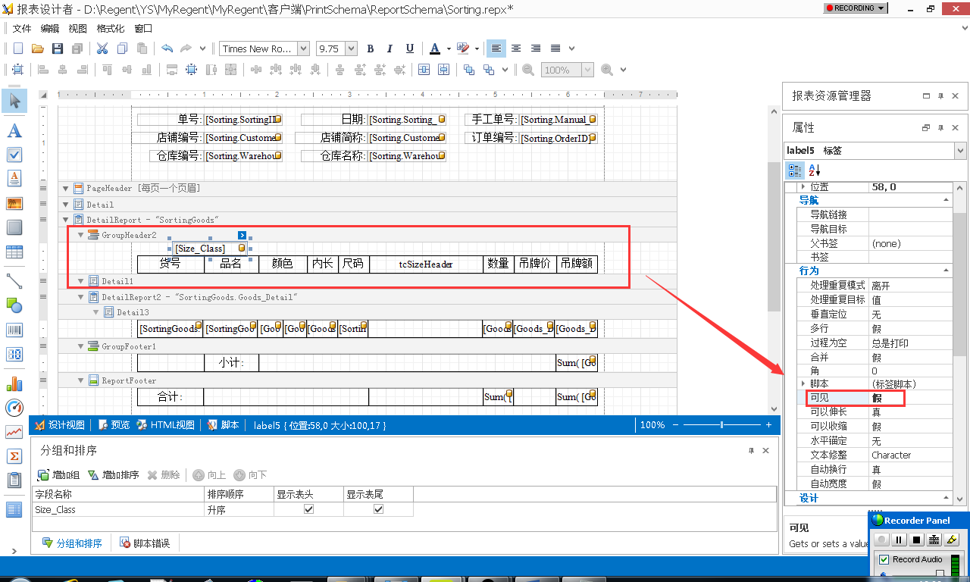

三、设置分组

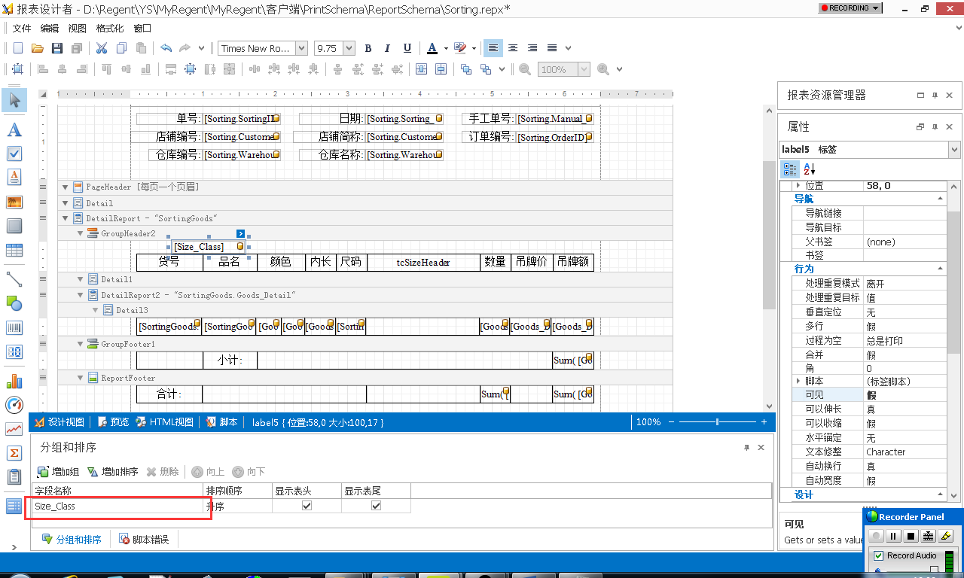

四、设置关联性

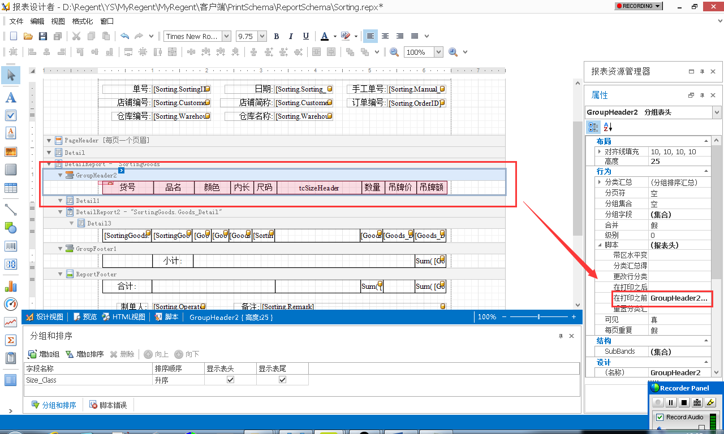

五、隐藏尺码类别

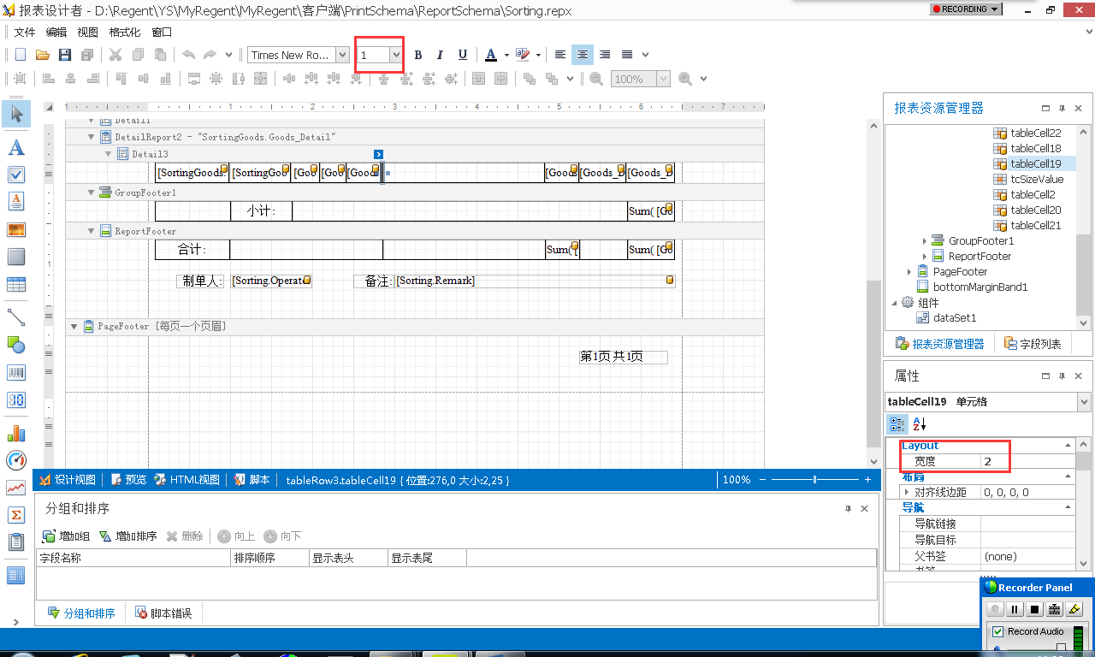

六、打印效果

